**Project Plan**

Project Name: Gradebook, Attendance and Seating Chart Project

Created By: Ryan Luong and Lydia Munoz (Group 2 Middle School)

**Introduction:**

The purpose of this project is to design a Middle School Management System. Our goal is to develop a secure, fast, dependable, user-friendly system that will allow the user to add new students, while keeping track of current student information as well instructor information.

**Scope:**

* The system includes a login screen that will allow the user to enter their user - name and password. They can be identified as an Administrator, the Academic Officer, or an instructor. If the user forgets their login information they are taken to another screen where they can recover the information.
* The Administrator is the highest level of security, you are allowed to retrieve information on employees, set salary, and Instructor data. You can also register new students and access guardian information, as well keep track of student and teacher attendance, generate reports, and add new classes.
* The Academic Officer is allowed to add, edit, and remove students from the database. Keep attendance on both the teacher and the student, can contact parents as needed, as well as be able to print and generate reports to include attendance, grades, student schedules, and classes.
* As an instructor you have access to student information, grades, attendance, and seating charts.
* All reports will be printed out in HTML files and they will include teacher and student attendance, class schedules, and student grades.
* Each of these modules has a specific role in the system that identifies it as a comprehensive School Management System. However, this system is not web based. The following are the main features/modules that will be used in this system:
* Administrative Module
* Academic Officer Module
* Instructor Module

**Programming Languages:**

Project will be completed using C# programming language with MSSQL for the database.

**Terms and Definitions:**

HTML (Hypertext Markup Language): Ability to publish online documents with headings, texts, tables, lists, photos, etc.

**Summary:**

This project will require the use of several screens for the user to navigate through either as an Administrator or an Instructor. The sample screens will be attached to this documentation.

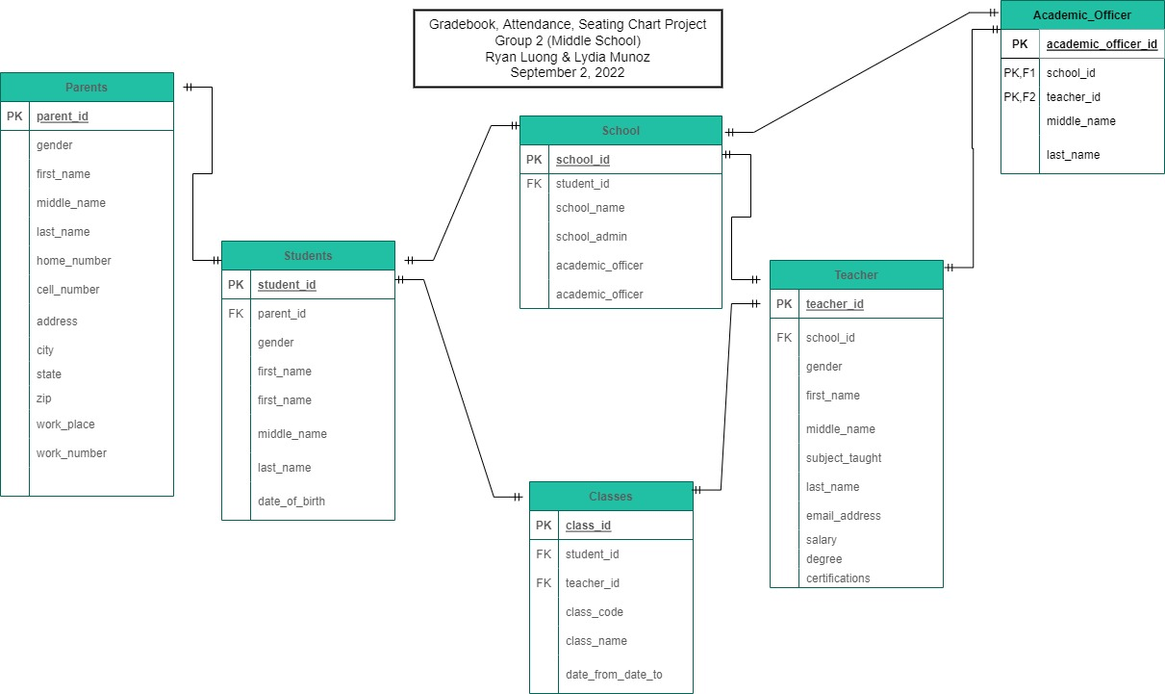

Administrator Module:

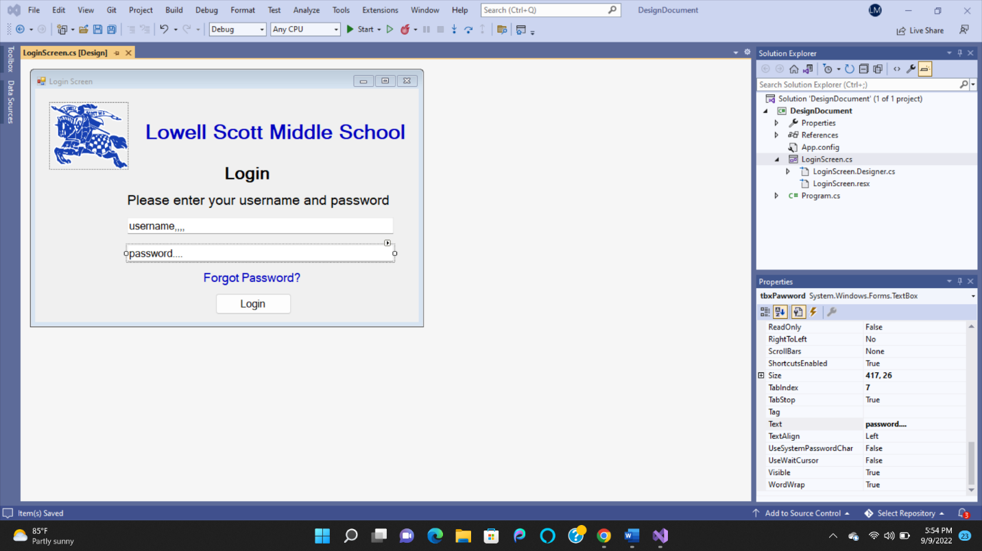

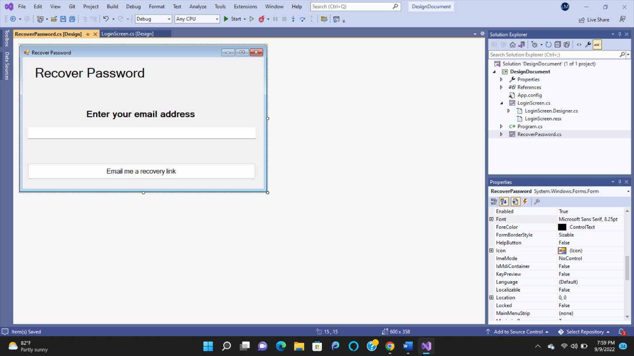

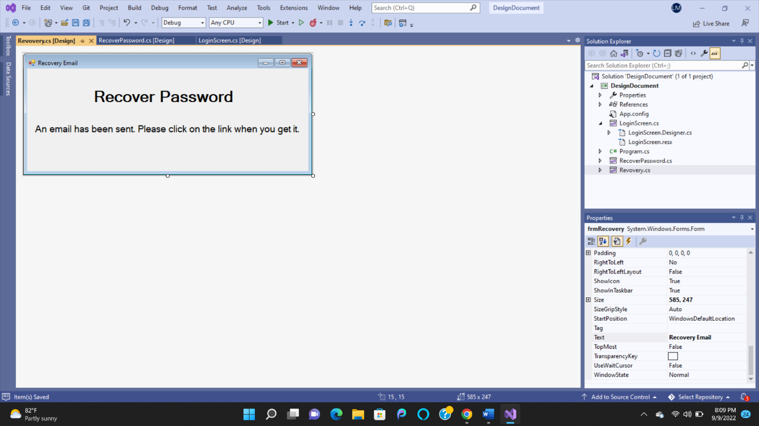

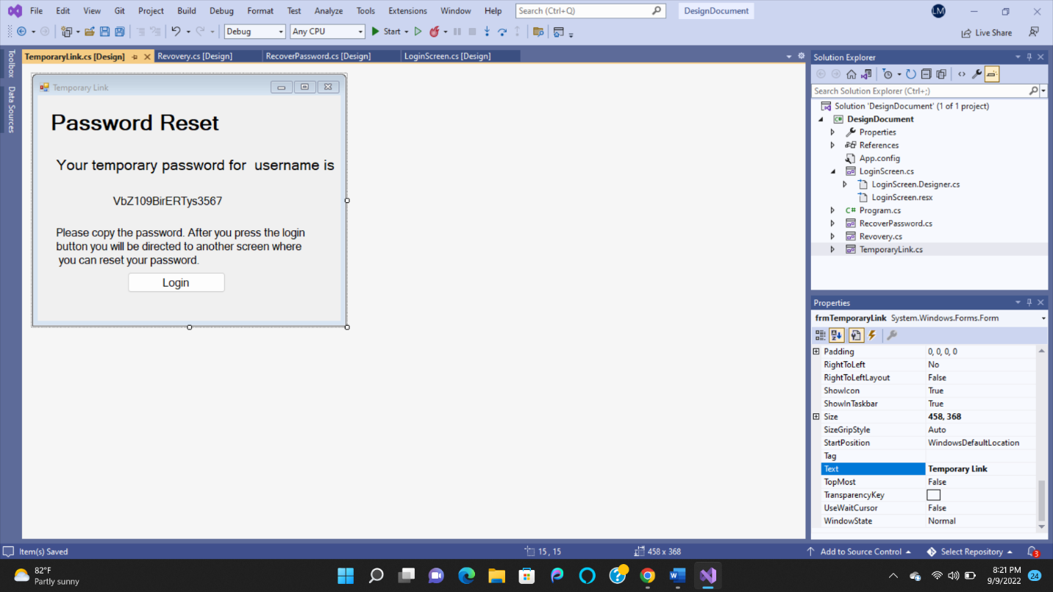

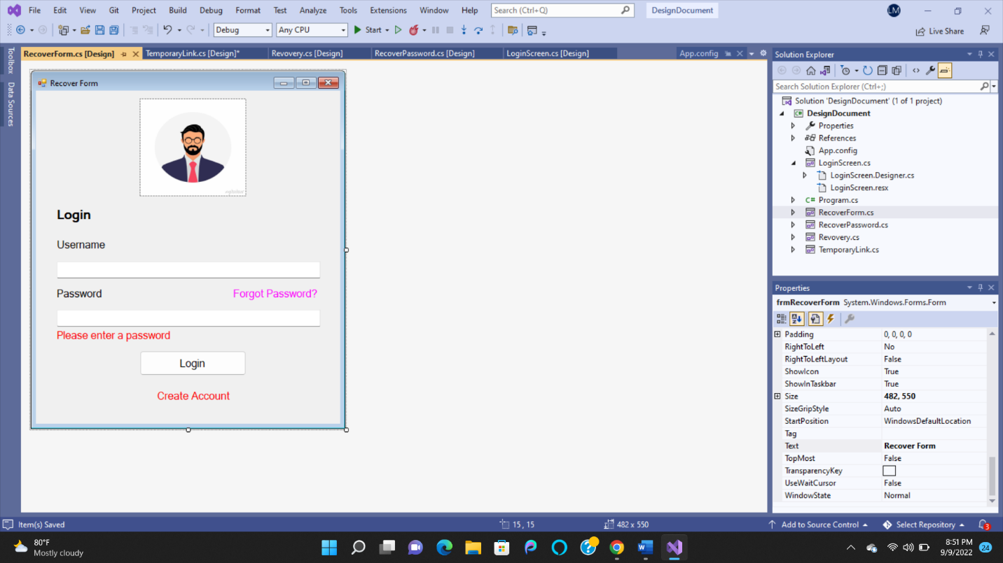

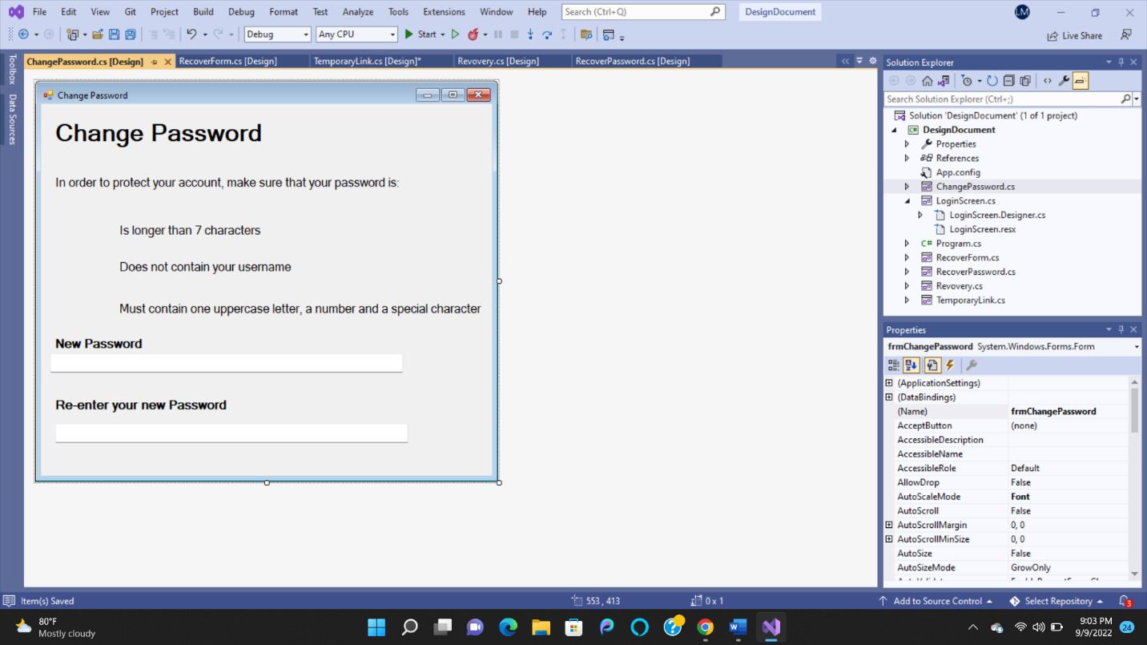



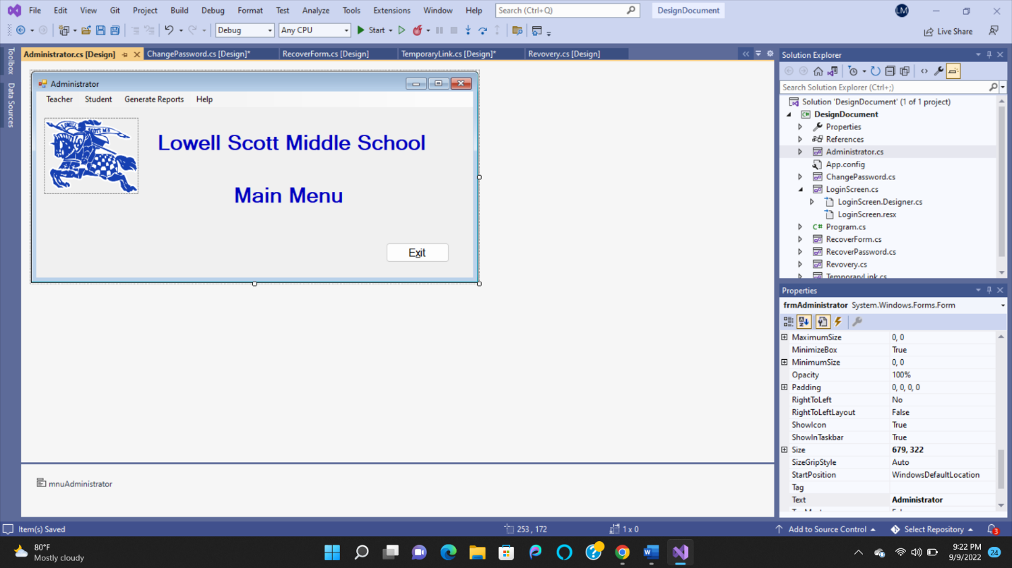

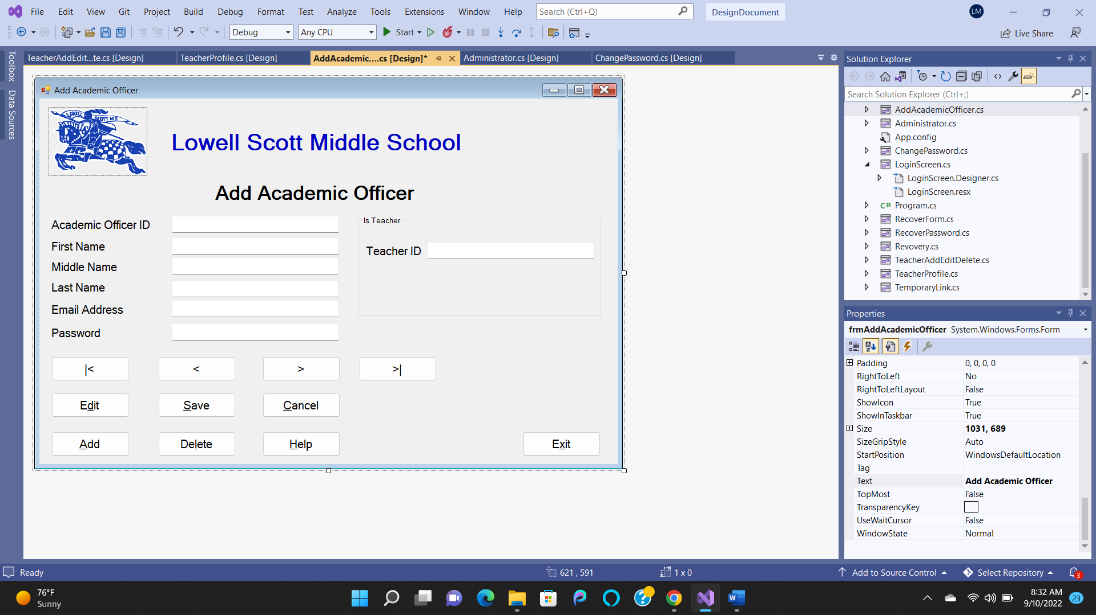

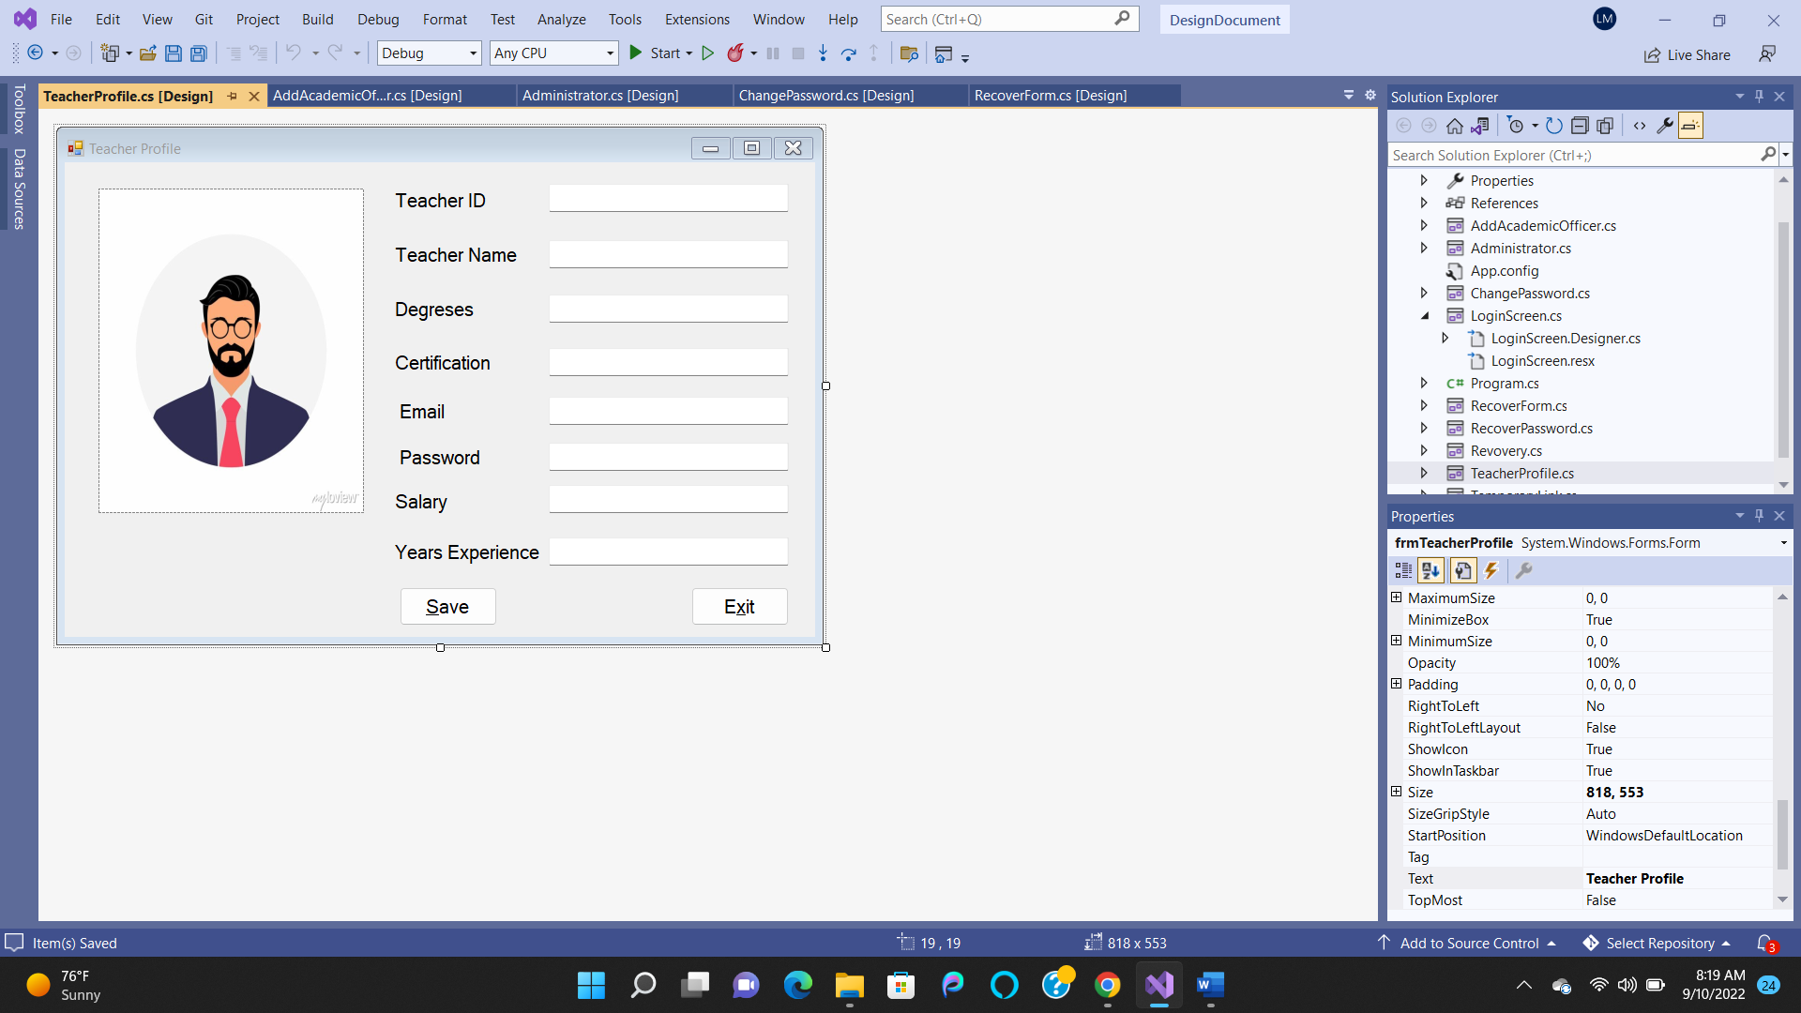

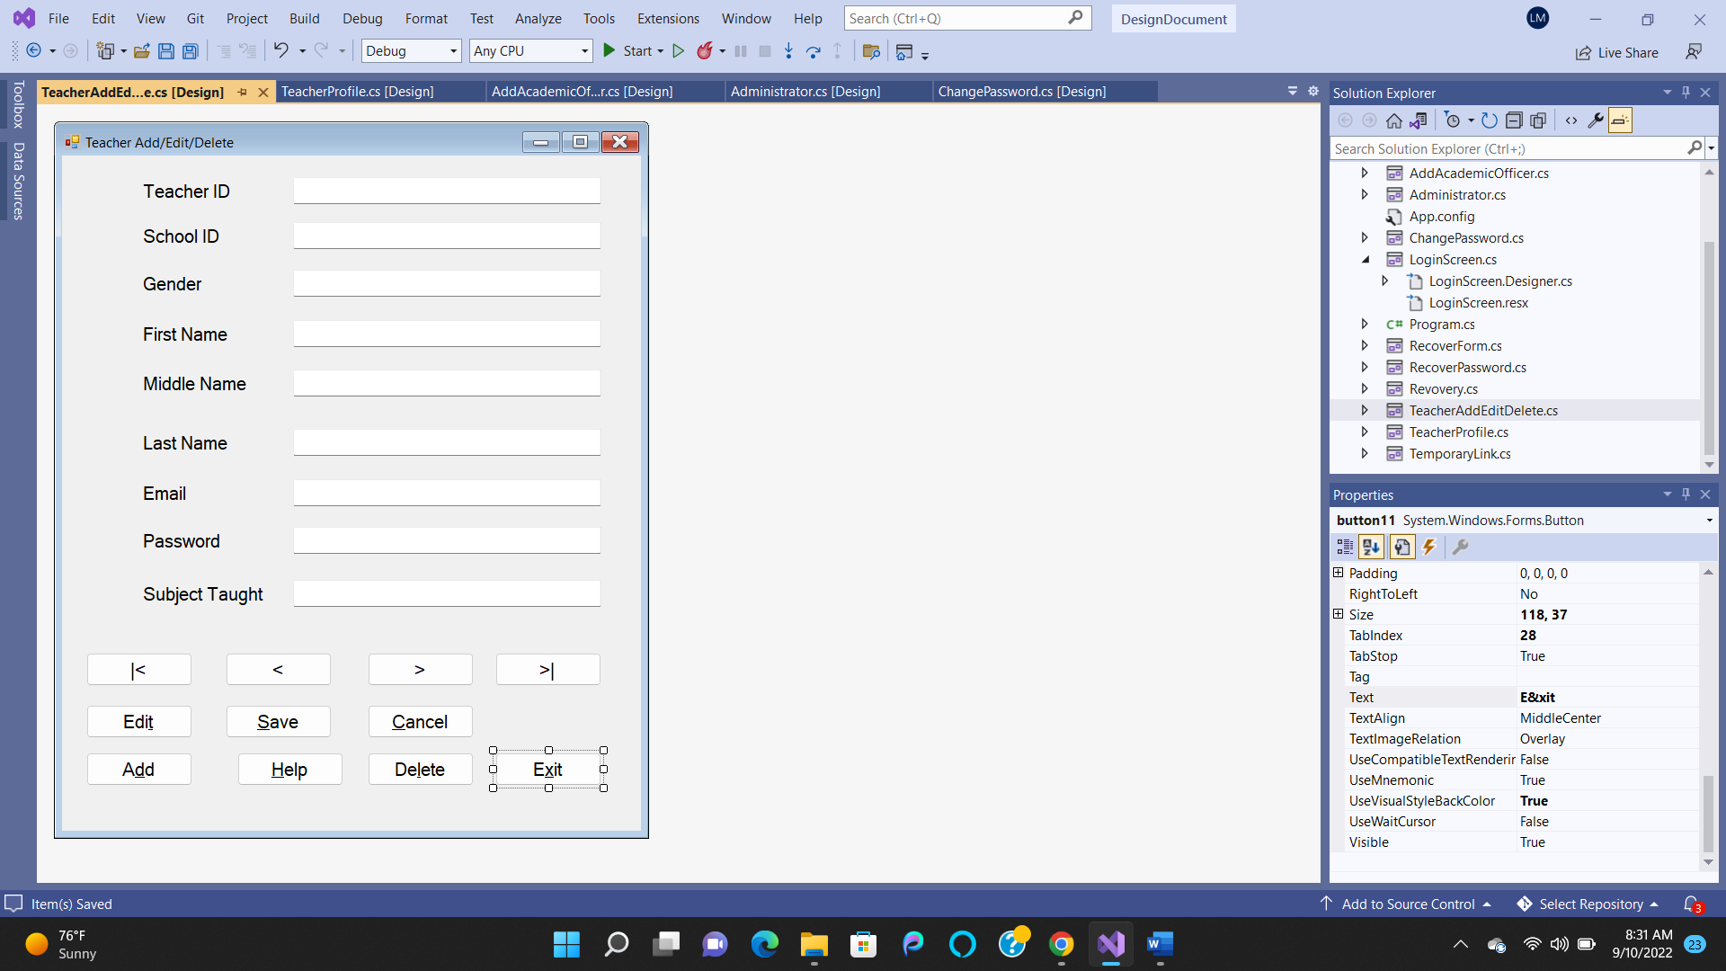

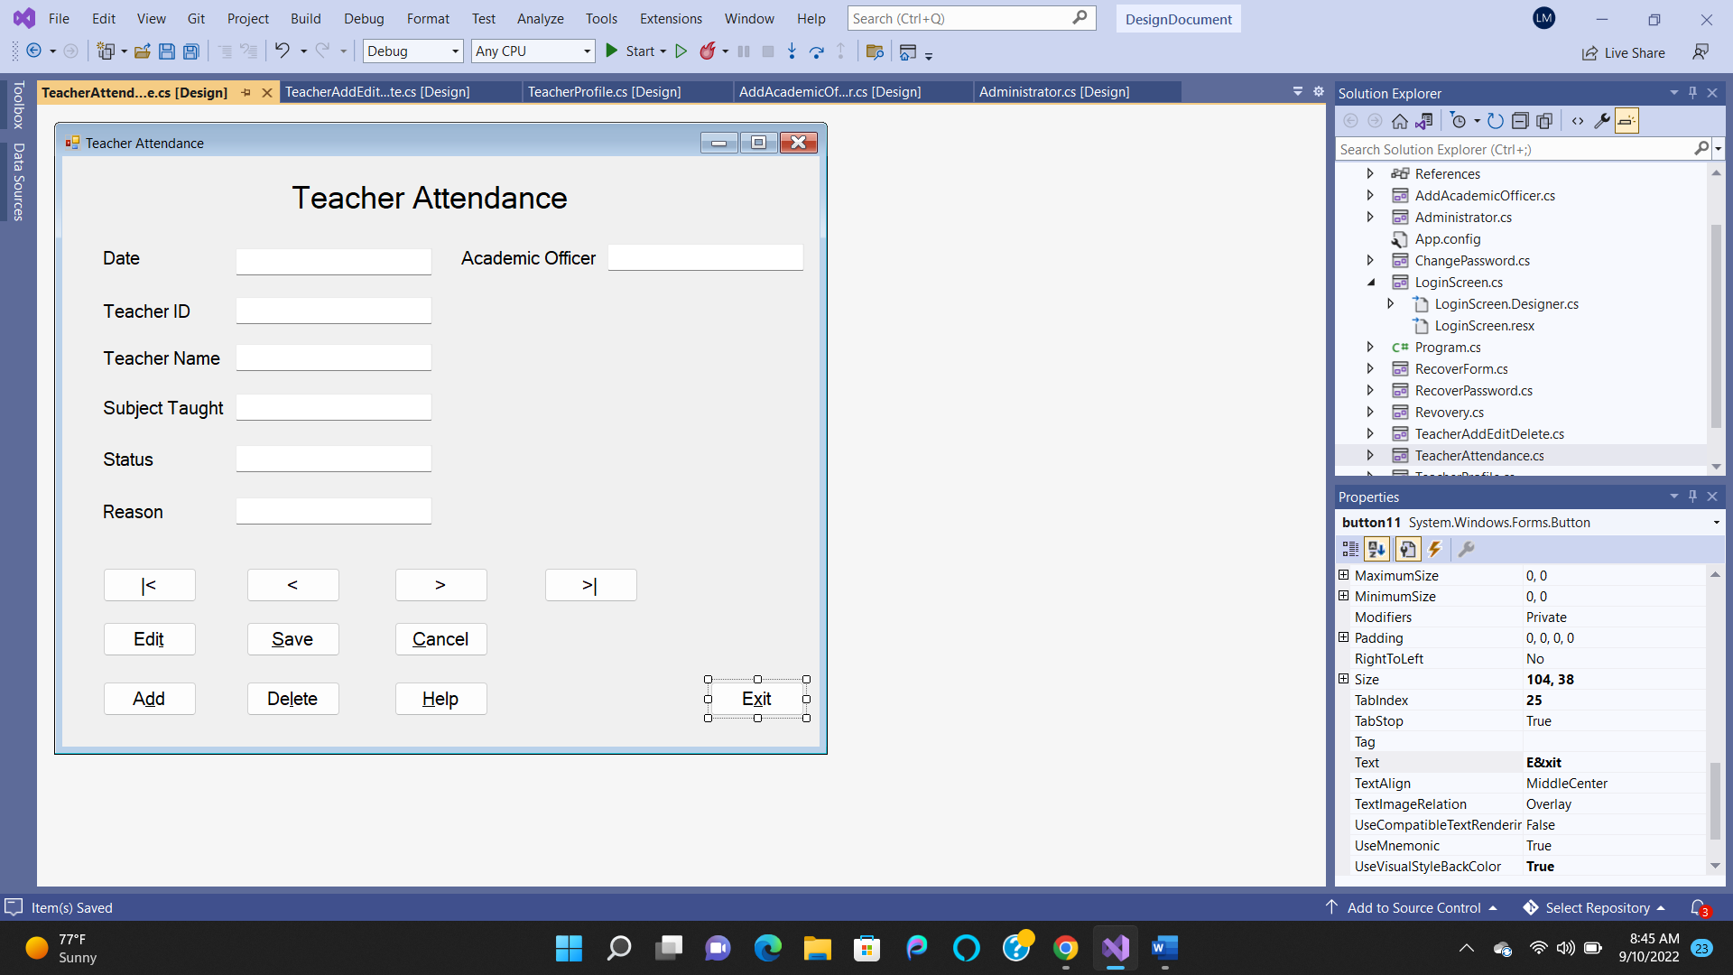

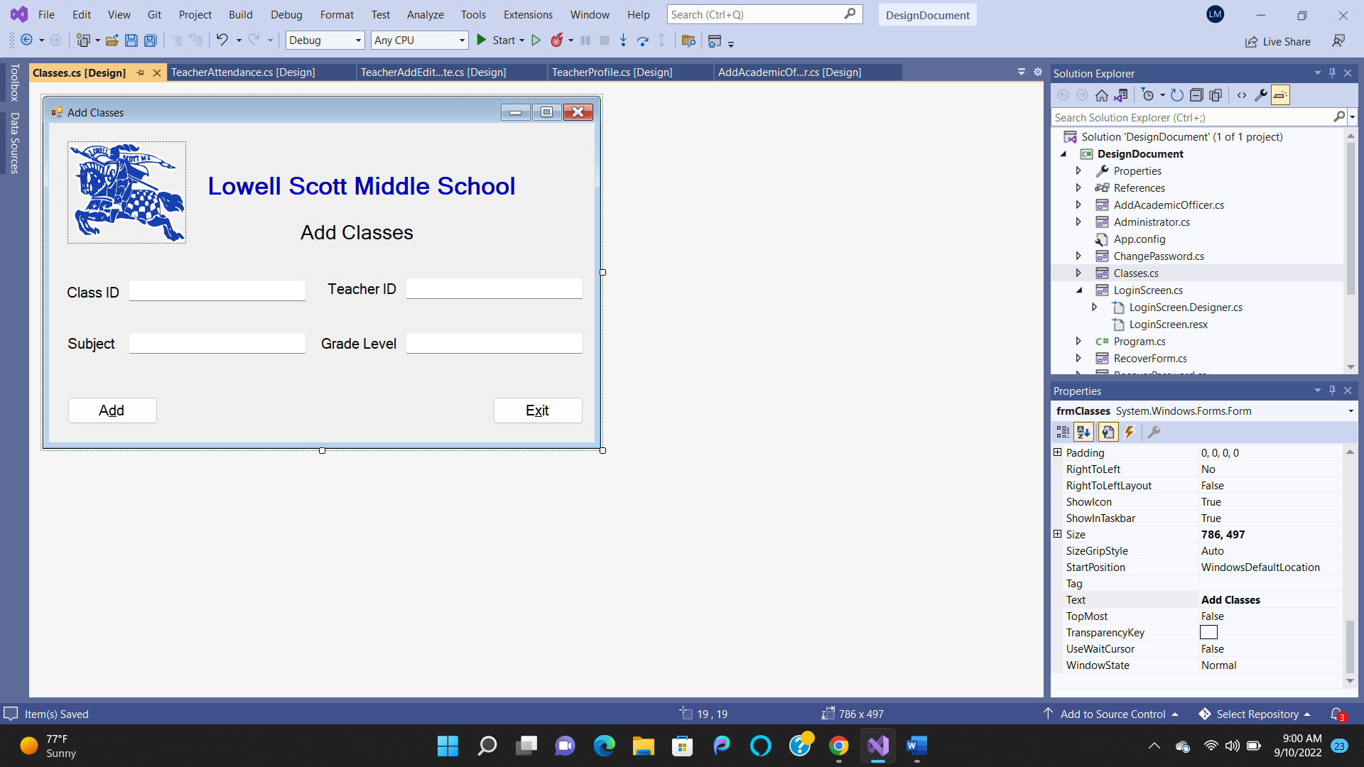

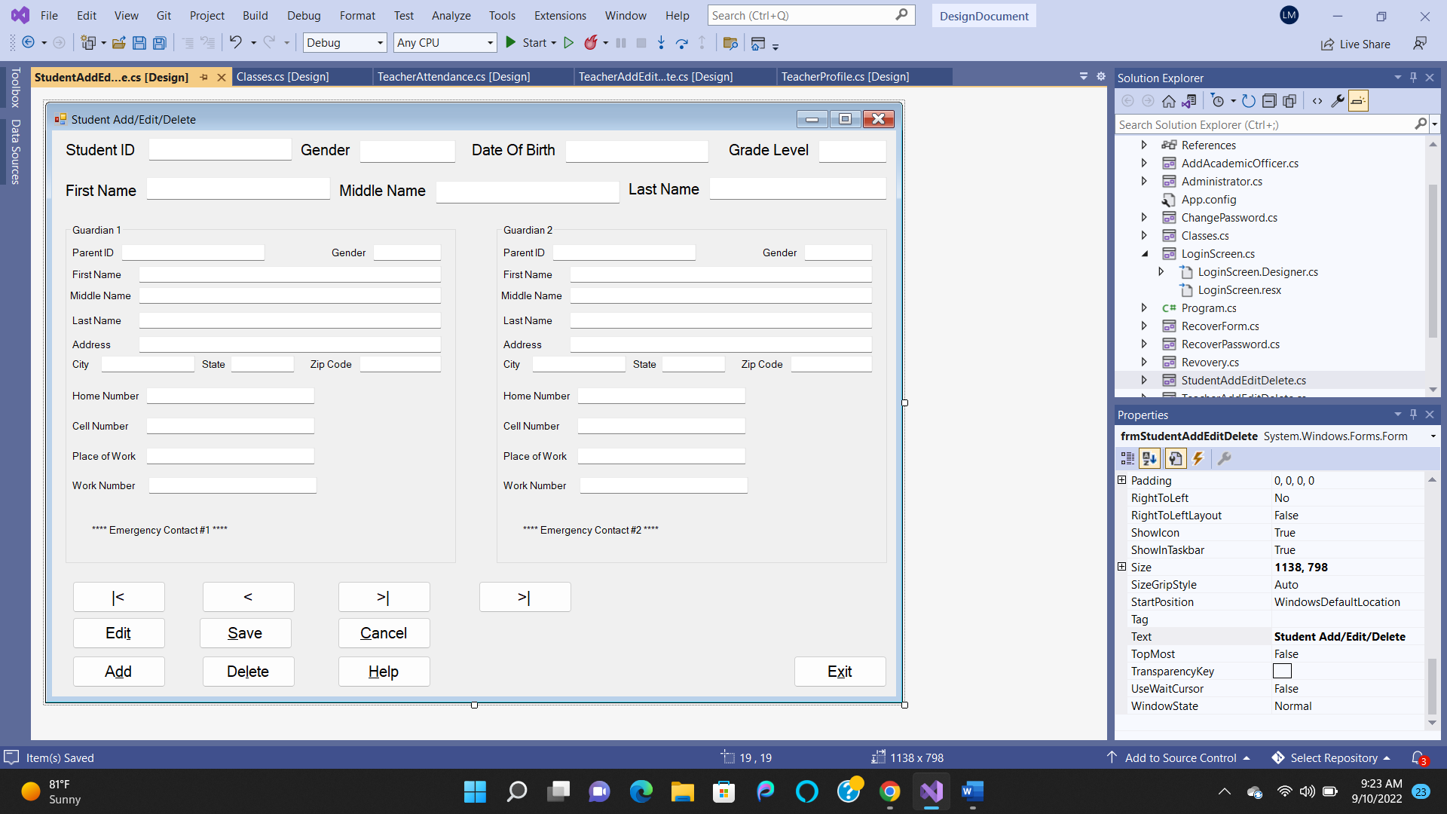

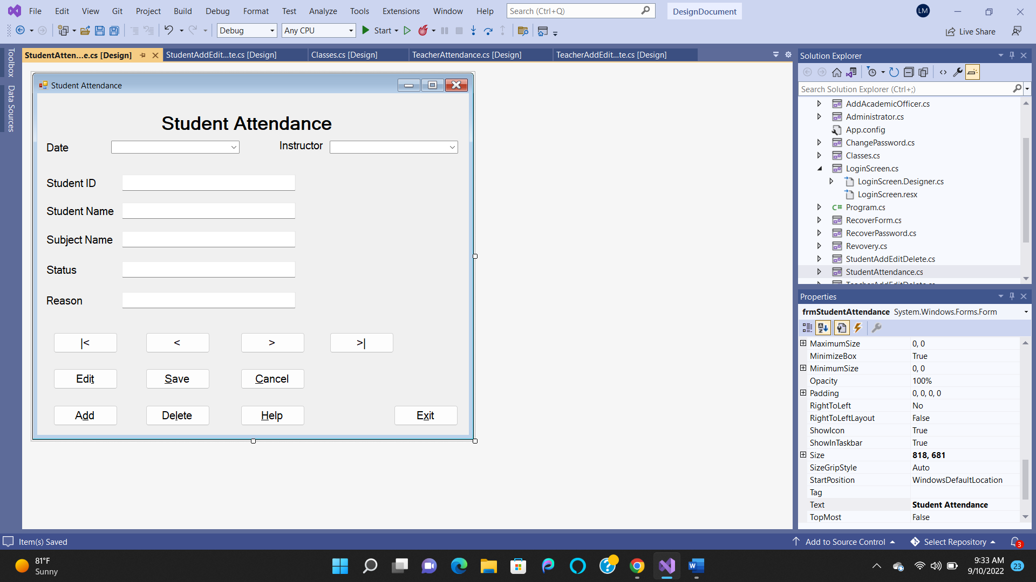

Academic Officer:















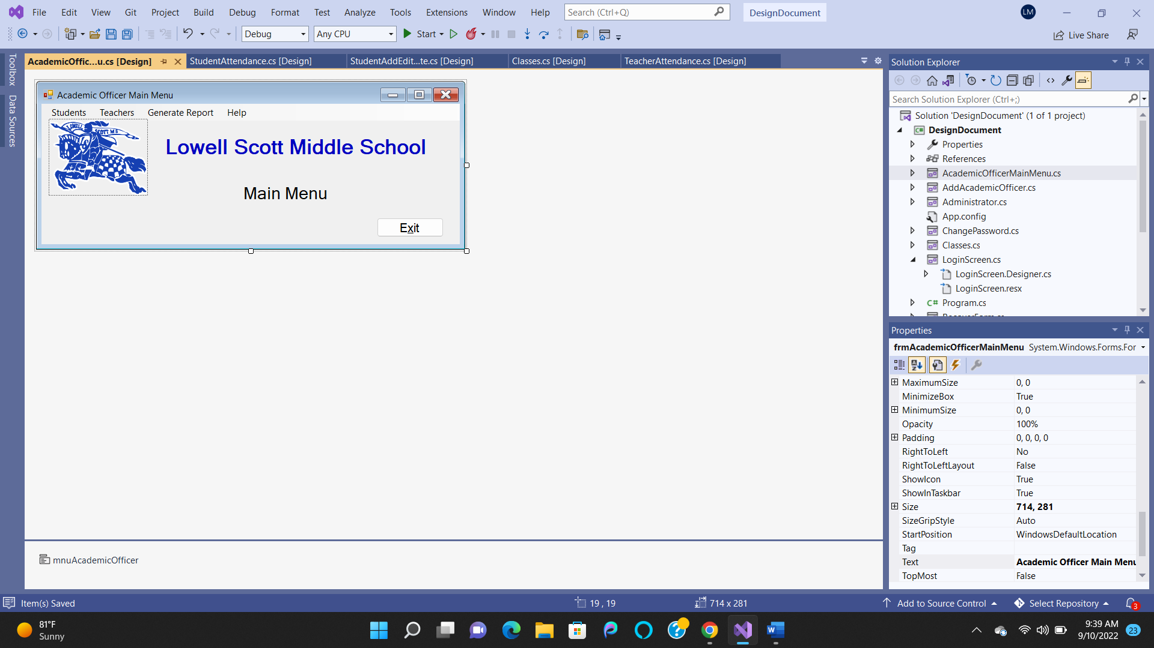











Teacher Module:















